# CHAPTER 1 INTRODUCTION

The technology aims in imparting tremendous knowledge oriented technical innovations these days. Deep Learning is one among the interesting domain that enables the machine to train itself by providing some datasets as input and provides an appropriate output during testing by applying different learning algorithms.

Nowadays Attendance is considered as an important factor for both the student as well as the teacher of an educational organization. With the advancement of the deep learning technology the machine automatically detects the attendance performance of the students and maintains a record of those collected data.

In general, the attendance system of the student can be maintained in two different forms namely,

* Manual Attendance System (MAS)
* Automated Attendance System (AAS).

Manual Student Attendance Management system is a process where a teacher concerned with the particular subject need to call the students name and mark the attendance manually. Manual attendance may be considered as a time-consuming process or sometimes it happens for the teacher to miss someone or students may answer multiple times on the absence of their friends.

So, the problem arises when we think about the traditional process of taking attendance in the classroom. To solve all these issues, we go with Automatic Attendance System (AAS).

Automated Attendance System (AAS) is a process to automatically estimate the presence or the absence of the student in the classroom. AAS uses various types of biometric techniques and approaches for maintaining student attendance automatically. Smart Attendance Using Face Recognition (SAUFR) is one of that techniques.

In Smart Attendance Using Face Recognition (SAUFR) system we are using face detection technique for marking up attendance of student. In Smart Attendance Using Face Recognition (SAUFR) system respected teachers are the authorized person which are allowed to capture and maintained attendance of student. In this system only those

teaching staffs are allowed to access this system who get authentication from the admin of the system. Admin has full authority to give authentication to the student as well as teacher for accessing this system.

# CHAPTER 2 LITERATURE REVIEW

K.Senthamil Selvi et.al. [3] “Face recognition-based Attendance marking system”. In this projected work, sort to find the attendance, positions and face descriptions in classroom lecture, we projected the presence administration system based on face detection in the classroom lecture. The system estimates the presence and the location of each student by continuous inspection and footage. The result of our beginning experiment shows continuous inspection improved the performance for estimation of the attendance.

Mr.C.S.Patil et.al. [4] “Student Attendance Recording System Using Face Recognition with GSM Based”, Student footage system using face validation was considered and implemented. It was tested with dissimilar face images. This idea is working properly with different panel. All windows are running separately and equivalent. If appreciation is to participate as a viable biometric for validation, then a further order of improvement in detection score is necessary. Under controlled condition, when lighting and pose can be controlled, this may be possible. It is more likely, that future improvement will rely on making better use of video knowledge and employing fully 3D face models.

Muhammad Fuzail et.al. [5] “Face Detection System for Attendance of Class’ Students”, An regular attendance supervision system is a essential tool for any LMS. Most of the existing system are time consuming and necessitate for a semi instruction manual work from the instructor or students. This approach aims to explain the issues by integrates face detection in the procedure. Even though this method still lacks the capability to identify each student in attendance on class, there is still much more room for enhancement. Since we implement a modular approach, we can get better different module until we reach an acceptable detection and identification rate. Another issue that has to be taken in consideration in the opportunity is a process to ensure users privacy. Whenever you like a representation is stored on servers, it must be impossible for a person to use that image.

Mathana Gopala et. al. [6] “Implementation of Automated Attendance System using Face Recognition”, automated presence System has been envision for the purpose of falling the errors that occur in the conventional (manual) attendance taking system. The aim is to

computerize and make a system that is useful to the institute such as an organization. The efficient and exact method of attendance in the office atmosphere that can reinstate the old manual methods. This technique is secure enough, reliable and available for use. No need for dedicated hardware for installing the system in the office. It can be constructed using a camera and computer.

# CHAPTER 3 PROBLEM STATEMENT

This system developed to reduce the manual work and avoid redundant data. By maintaining the attendance manually, the efficient reports cannot be generated. The system can generate efficient and consolidate report based on the attendance. As the attendances are maintained in registers it has been a tough task for staff to maintain for long time. Instead the software can keep long and retrieve the information when needed.

Manual attendance may be considered as a time-consuming process or sometimes it happens for the teacher to miss someone or students may answer multiple times on the absence of their friends.

Daily attendance marking is a common and important activity in schools and colleges for checking the performance of students. Manual Attendance maintaining is difficult process, especially for large group of students. Some automated systems developed to overcome these difficulties, have drawbacks like cost, fake attendance, accuracy. Manual systems attendance management can lead to many problems such as:

1. Inconsistency in data entry and generate errors
2. System is fully dependent on skilled individuals
3. Time consuming and costly to produce reports
4. Entry of false information
5. Lack of security
6. Duplication of data entry

To overcome these drawbacks, there is need of smart and automated attendance system.

# CHAPTER 4 SYSTEM ANALYSIS

An attendance Management System supports Face Recognition algorithmic program. This method mechanically detects the student once he/she enters the category area and marks the attendance by recognition. This could be used to avoid proxy attendance. The matter with this approach is that it captures just one student image at a time once he/she enters the classroom. A camera is setup in the middle of the class room at a suitable height to get the full view of the class till the last bench. After the students have been seated the camera will take an image and starts the process of face detection using the techniques and methods discussed in the methodology section. After this the program will automatically make a folder in the database having the students to be recognized. The already placed images of each student is taken and used from database for image recognition. The images will be fetched and compared with each of the entry in the database and hence will be checked whether the student is present in the class or not. If there is no match the program will move on to the next picture.

The steps involved in the project are:

1. Create Database
2. Training Faces
3. Face Detection
4. Face Recognition
5. Post processing

## 4.1. Create Database

The first step in the Attendance System is to create a database of faces that we will be using. Different subjects are taken and a camera is used to detect faces and record their frontal face. The number of frames to be taken for consideration can be modified to our accuracy. These images are then stored in the database with the Registration ID.

## 4.2 Training Faces

The images area unit saved in gray scale, as all faces is recorded by a category camera. The LBPH recognizer is employed to coach these faces because the coaching set res olution and therefore the recognized face resolutions are totally different.

## 4.3. Face Detection

The trained faces data is stored in an .yml format which contains all the training data. The detector looks for the face using the Harrcascade frontal face module.

## 4.4 Face Recognition

The saved and trained faces are stored and the detected faces are compared to the IDs of the students, and recognized. Real Time recording is done to ensure the accuracy of the system.

## E. Post Processing

The backend of this project will be developed in MySQL, Wamp and Apache. If not, an offline spreadsheet can be used to mark attendance for the recognized faces. The teacher can specify the time by which the camera will be tracking the class.

# CHAPTER 5 REQUIREMENT ANALYSIS AND DESIGN

## Software Requirements

* + - Operating System: Windows 7,8,10, Raspbian Stretch.
    - Front End: HTML, CSS, JavaScript.
    - Back End: PHP, Python. JavaScript.
    - Web Technology: HTML, CSS, PHP, Django.
    - Database management: MySQL.

## Hyper Text Markup Language: (HTML)

Hypertext Markup Language (HTML) is the standard markup language for documents designed to be displayed in a web browser. It can be assisted by technologies such as Cascading Style Sheets (CSS) and scripting languages such as JavaScript. Web browsers receive HTML documents from a web server or from local storage and show the documents into multimedia web pages. HTML describes the structure of a web page semantically and originally included cues for the appearance of the document. HTML provides a means to create structured documents by denoting structural semantics for text such as headings, paragraphs, lists, links, quotes and other items. By this, with HTML you can create your own Website.

## Cascading Style Sheet (CSS)

Cascading Style Sheets (CSS) is a style sheet language used for describing the presentation of a document written in a markup language like HTML. CSS is designed to enable the separation of presentation and content, including layout, colors, and fonts. This separation can improve content accessibility, provide more flexibility and control in the specification of presentation characteristics, enable multiple web pages to share formatting by specifying the relevant CSS in a separate .css file, and reduce complexity and repetition in the structural content. Separation of formatting and content also makes it feasible to present the same markup page in different styles for different rendering methods, such as on-screen, in

print, by voice and on Braille-based tactile devices. CSS also has rules for alternate formatting if the content is accessed on a mobile device. The name cascading comes from the specified priority scheme to determine which style rule applies if more than one rule matches a particular element. This cascading priority scheme is predictable. In addition to HTML, other markup languages support the use of CSS including XHTML, plain XML.

## JavaScript:(JS)

JavaScript often abbreviated as JS, is an interpreted programming language. JavaScript is high-level, often just-in-time compiled, and multi-paradigm. It has curly- bracket syntax, dynamic typing, prototype-based object-orientation, and first-class functions. Alongside HTML and CSS, JavaScript is one of the core technologies of the World Wide Web. JavaScript enables interactive web pages and is an essential part of web applications. The vast majority of websites use it for client-side page behavior, and all major web browsers have a dedicated JavaScript engine to execute it. As a multi-paradigm language, JavaScript supports event-driven, functional, and imperative programming styles. Originally used only in web browsers, JavaScript engines are also now embedded in server-side website deployments and non-browser applications. Although there are similarities between JavaScript and Java, including language name, syntax, and respective standard libraries, the two languages are distinct and differ greatly in design.

## PHP: Hypertext Preprocessor

PHP is a popular general-purpose scripting language. PHP is a recursive acronym for "PHP: Hypertext Preprocessor". The PHP is a programming language that allows web developers to create dynamic content that interacts with databases. PHP is basically used for developing web-based software applications. PHP is a server-side scripting language that is embedded in HTML. It is used to manage dynamic content, databases, session tracking, even build entire e-commerce sites. PHP is a widely-used, open source scripting language. PHP scripts are executed on the server. PHP is free to download and use. PHP files can contain text, HTML, CSS, JavaScript, and PHP code. PHP code is executed on the server, and the result is returned to the browser as plain HTML.PHP files have extension ".php". PHP runs on various platforms (Windows, Linux, Unix, Mac OS X, etc.).PHP is compatible with almost all servers used today (Apache, IIS, etc.).PHP supports a wide range of databases. PHP is free. PHP is easy to learn and runs efficiently on the server side.

## Python:

Python is an interpreted, high-level, general-purpose programming language. Python's design philosophy emphasizes code readability with its notable use of significant whitespace. Its language constructs and object-oriented approach aim to help programmers write clear, logical code for small and large-scale projects. Python is dynamically typed and garbage-collected. It supports multiple programming paradigms, including procedural, object-oriented, and functional programming. Python interpreters are available for many operating systems. Python’s elegant syntax and dynamic typing, together with its interpreted nature, make it an ideal language for scripting and rapid application development in many areas on most platforms. The Python interpreter and the extensive standard library are freely available in source or binary form for all major platforms from the Python Web site.

* + - * Following are important characteristics of Python Programming –
* It supports functional and structured programming methods as well as OOP.
* It can be used as a scripting language or can be compiled to byte-code for building large applications.
* It provides very high-level dynamic data types and supports dynamic type checking.
* It supports automatic garbage collection.
* It can be easily integrated with C, C++, COM, ActiveX, CORBA, and Java.

## Django:

Django is a Python-based free and open-source web framework, which follows the model-template-view (MTV) architectural pattern. It is maintained by the Django Software Foundation (DSF), an independent organization established as a non-profit. Django was created in the fall of 2003, when the web programmers at the Lawrence Journal-World newspaper, Adrian Holovaty and Simon Willison, began using Python to build applications. Jacob Kaplan-Moss was hired early in Django's development shortly before Simon Willison's internship ended. It was released publicly under a BSD license in July 2005. The framework was named after guitarist Django Reinhardt. Django's primary goal is to ease the creation of complex, database-driven websites. The framework emphasizes reusability and "pluggability" of components, less code, low coupling, rapid development, and the principle of don't repeat yourself. Python is used throughout, even for settings files and data models. Django also

provides an optional administrative create, read, update and delete interface that is generated dynamically through introspection and configured via admin models. Some well-known sites that use Django include the Public Broadcasting Service, Instagram, Mozilla. It was used on Pinterest, but later the site moved to a framework built over Flask.

## MySQL:

A database is a separate application that stores a collection of data. Each database has one or more distinct APIs for creating, accessing, managing, searching and replicating the data it holds. Other kinds of data stores can also be used, such as files on the file system or large hash tables in memory but data fetching and writing would not be so fast and easy with those type of systems.

MySQL is a relational database management system based on the Structured Query Language, which is the popular language for accessing and managing the records in the database. MySQL is open-source and free software under the GNU license. It is supported by Oracle Company**.**

## Hardware Requirements:

* + 1. **Raspberry Pi:** The Raspberry Pi is a low cost, credit-card sized computer that plugs into a computer monitor or TV, and uses a standard keyboard and mouse. It is a capable little device that enables people of all ages to explore computing, and to learn how to program in languages like Scratch and Python. The Raspberry Pi has the ability to interact with the outside world, and has been used in a wide array of digital maker projects, from music machines and parent detectors to weather stations and tweeting birdhouses with infra-red cameras.
    2. **Camera**: A camera is an optical instrument used to record images. At their most basic, cameras are sealed boxes (the camera body) with a small hole (the aperture) that let light in to capture an image on a light-sensitive surface (usually photographic film or a digital sensor). Cameras have various mechanisms to control how the light falls onto the light-sensitive surface. Lenses focus the light entering the camera, the size of the aperture can be widened or narrowed to let more or less light into the camera, and a shutter mechanism determines the amount of time the photo-sensitive surface is exposed to the light.

# CHAPTER 6 SYSTEM DESIGN

## Data Flow Diagram:

This technique uses graphical tools called Data flow Diagram (DFD) to depict the information flow through the system and the transformation that are applied to it between the input and output stages.

A DFD may be used to represent a system or software at any level of abstraction; the lowest level of abstraction is presented by the source code. DFD may be partitioned into levels that represent increasing information flow and functional details. Level 0 DFD is called a functional system model or context model and represents the entire software elements as a single-bubble with input and output data indicated by incoming and outgoing arrows respectively.

The level is then partitioned to reveal more details upon exploding the context diagram with TOP LEVEL DFD, which is nothing but the representation of the major function in the form of bubbles. In this DFD the external and data stores being used are also shown.

Lower level DFD do not show the external entities. The diagram does not explicitly indicate the sequence of processing rather it depicts the information flow. Initially the functions’ that the system was required to perform are identified. Concentrating on each function the subtasks to be performed are further identified

## Modules

* + 1. Admin
    2. HOD
    3. Staff
    4. Student

## Student Module:

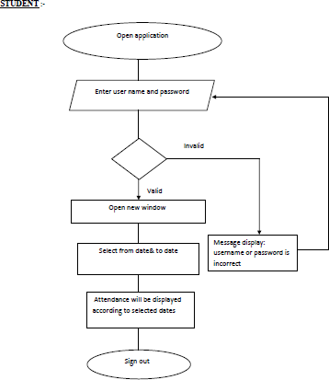

**Fig 6.1.1: Student module**

Above fig. shows the flow of student module. In which first student open the application and login with his/her unique username and password that is assigned to them at the time of registration. If their username and password are valid then open new window otherwise show the message username or password are invalid (incorrect). After successful login, student can see their attendance according to subject along with number of lectures present, number of lecture absent and attendance percentage.

## Staff module:

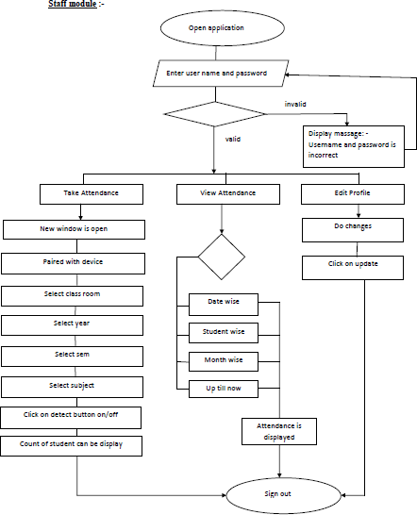

**Fig 6.1.2: Staff module**

Above fig. shows the flow of staff module. In which first staff open the application and login with his/her unique username and password that is assigned to them at the time of registration. If their username and password are valid then open new window otherwise show the message username or password are invalid (incorrect). After successful login staff having three options that are as follows:

* Take Attendance.
* View Attendance.
* Edit Profile.

Take Attendance: -

While staff click on the take attendance option new window is appear. That window consists of various fields like paired device, select class room, select year, select semester, select subject and detect button. Paired device is option by click on this the mobile device make connection with camera. For selecting particular class room select class option is given, similarly for selecting year, semester and subject select year, select semester, select subject option is used respectively. While clicking on detect button it enables the camera and start marking attendance. After end of particular given session, it stops and gives the count of number of present students.

View Attendance: -

While staff click on the view attendance option new window is appear. That window consists of various option like date wise, student wise, monthly, up till now. While clicking on date wise option it gives date selector in which staff selects form date and to date after selecting date’s staff click on view. It gives the list of students and their attendance with respect to subject within the given date. While clicking on student wise option it gives search bar and list of all the students along with name, branch, subject, present count and percentage of attendance. While clicking on monthly option it gives monthly attendance sheet that consist attendance of a current month of all the students. While clicking on up till now option it gives overall attendance of all the students up till todays date.

Edit Profile: -

While staff click on the Edit profile option new window is appear. That window consists of one form that having following fields first name, middle name, last name, Email id, phone no, DOB (Date of Birth), address, branch, gender, username, password, confirm password and update button. When staff wants to update their profile, the given form is open, then staff fills form details and then click on update button staff update his/her profile.

## HOD Module: -

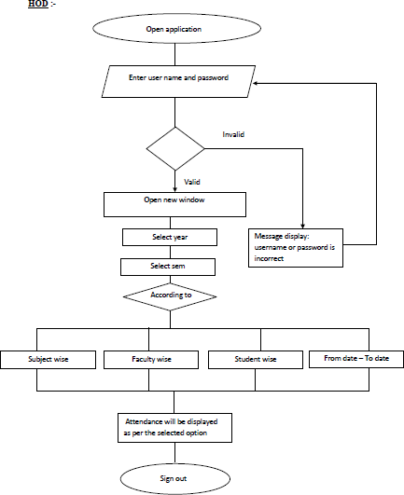

**Fig 6.1.3: HOD module**

Above fig. shows the flow of HOD module. In which first HOD open the application and login with his/her unique username and password that is assigned to them at the time of registration. If their username and password are valid then open new window otherwise show the message username or password are invalid (incorrect). After successful login new window is appear that gives two fields that is select year and select semester for selecting year and semester. After that HOD having four options that are as follows:

* Subject wise.
* Faculty wise.
* Student wise.
* From date – To date.

Subject wise: -

While HOD click on the subject wise option new window is appear. That window consists of list of all the subjects. As per the subject student attendance will be displayed.

Faculty wise: -

While HOD click on the Faculty wise option new window is appear. That window consists of list of all the staff. Various subject is taught by various teacher to various student. As per that attendance will be displayed.

Student wise: -

While HOD click on the student wise option new window is appear. That window consists of list of all the students with their attendance percentage.

From date – To date: -

While HOD click on From date – To date (i.e. date wise) option new window is appear. That window consists of date selector and view button. While click on view student’s attendance will be display as per selected dates.

## Python admin module: -

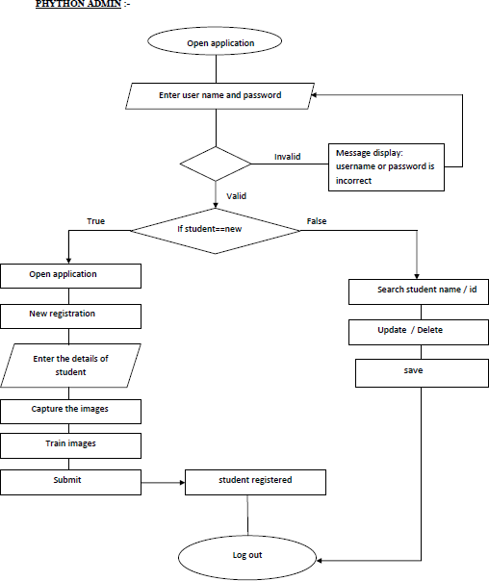

**Fig 6.1.4: Python admin module**

Above fig. shows the flow of python admin module. In which first admin open the application and login with his/her unique username and password that is assigned to them at the time of registration. If their username and password are valid then open new window otherwise show the message username or password are invalid (incorrect). After successful login new window is appear that consist of two option that are as follows:

* New registration.
* Already register.

New Registration: -

While admin click on the new registration option new window is appear. That window consists of one form that having following fields id, first name, middle name, last name,

Email id, phone no, DOB (Date Of Birth), address, branch, gender, year, semester, session, username, password, confirm password and capture, train, submit, cancel button. After filling the details admin click on the capture button that capture the set of images. And save that image with id, name and count of image i.e. id_name_count. After that admin click on train button that trains the images and make ratio and assign that ratio to id. Then after click on submit button details of student can be store in database.

Already Register: -

While admin click on the already register option, new window is appeared. That window consists of one search bar and list of all the students with two buttons update and delete in front of each student. While click on update button one form is open that having some fields like id, first name, middle name, last name, Email id, phone no, DOB (Date of Birth), address, branch, gender, year, semester, session, username, password, confirm password. After updating the details click on save button details have been updated. When student leave or detent in such case click on delete button particular student entry will be removed from database.

## PHP admin module:

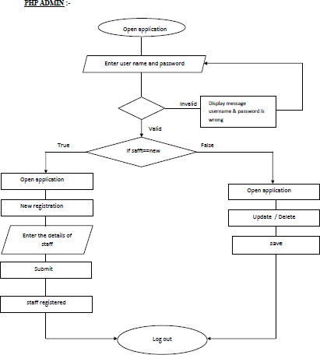

**Fig 6.1.5: PHP admin module**

Above fig. shows the flow of PHP admin module. In which first admin open the application and login with his/her unique username and password that is assigned to them at the time of registration. If their username and password are valid then open new window otherwise show the message username or password are invalid (incorrect). After successful login new window is appear that consist of two option that are as follows:

* New registration.
* Already register.

New Registration: -

While admin click on the new registration option new window is appear. That window consists of one form that having following fields first name, middle name, last name, Email id, phone no, DOB (Date of Birth), address, branch, gender, username, password, confirm password and submit, cancel buttons. After filling the details admin click on the submit button new staff is registered.

Already register: -

While admin click on the already register option new window is appeared. That window consists of one search bar and list of all the students with two buttons update and delete in front of each student. While click on update button one form is open that having some fields like first name, middle name, last name, Email id, phone no, DOB (Date of Birth), address, branch, gender, username, password, confirm password. After updating the details click on save button details have been updated. When staff leave at that time click on delete button particular staff entry will be removed from database.

**Use case diagram: -**

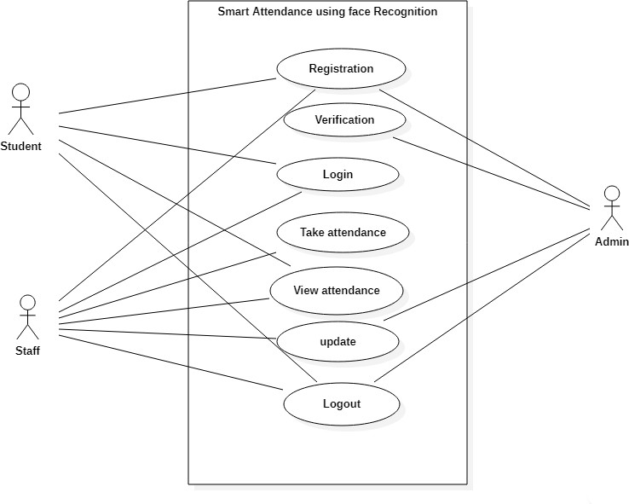

**Fig 6.1.6: Use case diagram**

Above fig show the use case diagram for smart attendance system using face recognition. In these actors are student, staff and admin. And cases are registration, verification, login, take attendance, view attendance, update, and logout. Actors are interacting with cases in such a way

Student:

* + Register: new registration of student.
  + Login: login with unique username and password.
  + View attendance: for view attendance of all subjects.
  + Logout: exit from current device.

Staff:

* Register: new registration of student.
* Login: login with unique username and password.
* View attendance: for view attendance of all students.
* Take attendance: mark the attendance.
* Update: to update his/her profile.
* Logout: exit from current device.

Admin:

* Register: new registration of student & staff.
* Login: login with unique username and password.
* Verification: verify the user is valid or not.
* Update: update student as well as staff details.
* Logout: exit from current device.

# CHAPTER 7 IMPLEMENTATION

Implementation is the stage of the project when the theoretical design is turned out into a working system. Thus, it can be considered to be the most critical stage in achieving a successful new system and in giving the user, confidence that the new system will work and be effective. The implementation stage involves careful planning, investigation of the existing system and its constraints on implementation, designing of methods to achieve changeover and evaluation of changeover methods.

There are four modules are in our project that are as follows:

* + Student
  + Staff
  + HOD
  + Admin

**Home page:**

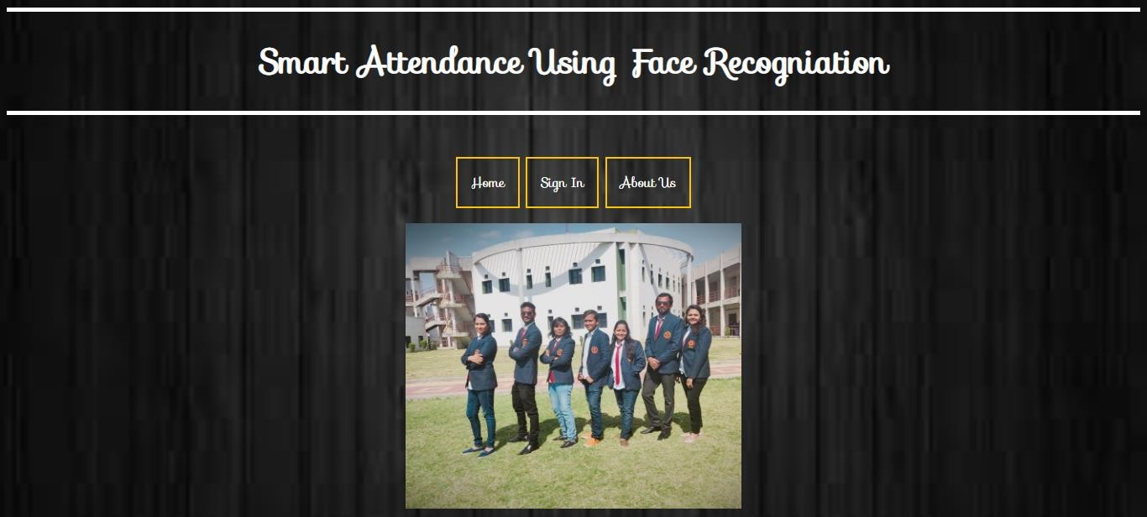

**Fig 7.1 Main home page**

**Student module: -**

**Login: -**

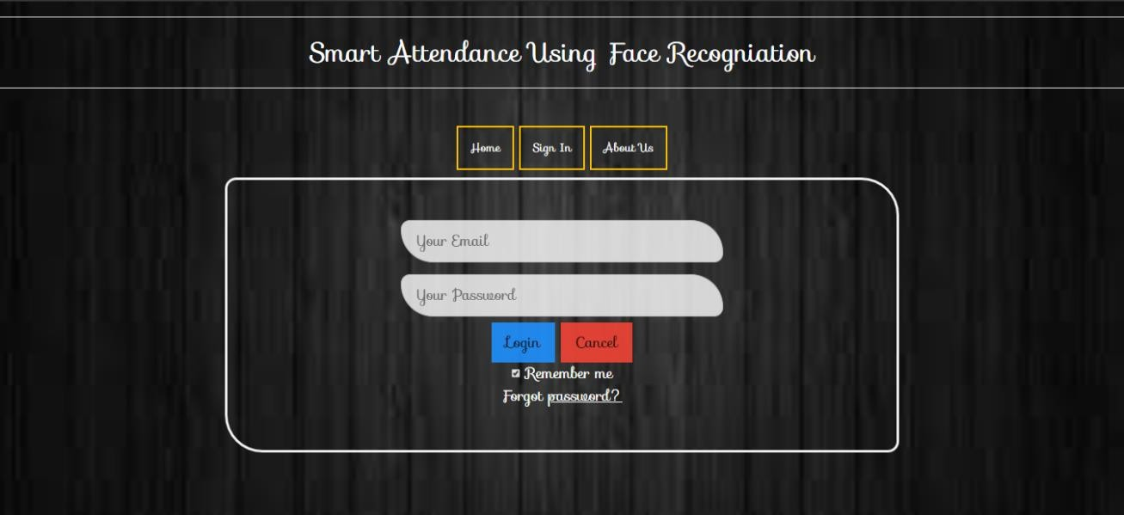

**Fig 7.2 Student login**

Above fig show the login page for student by using this web pages student can login. For successful login student need a valid username and password that was already given to student at the time of registration. This is the first step to view attendance in our Smart attendance system.

After successful login below shown window will be appeared.

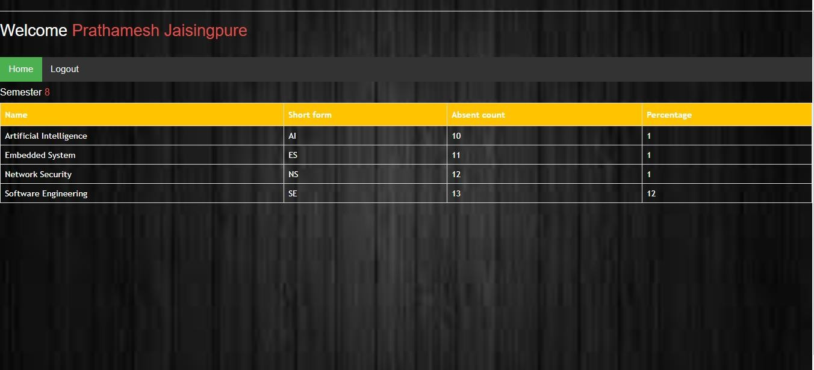

Fig 7.3 student attendance

When click on any subject name the following window will be opened.

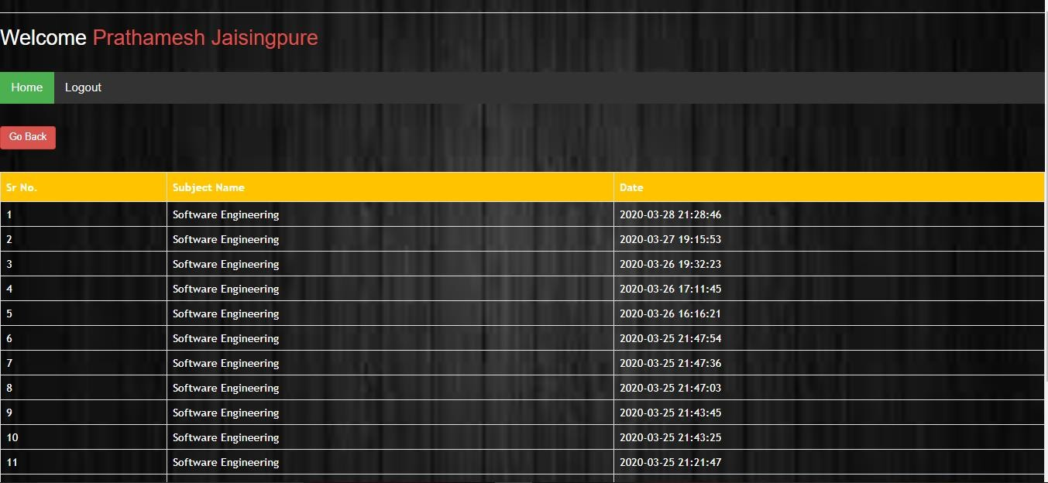

Fig 7.4 individual subject attendance

**Staff Module: -**

**Login: -**

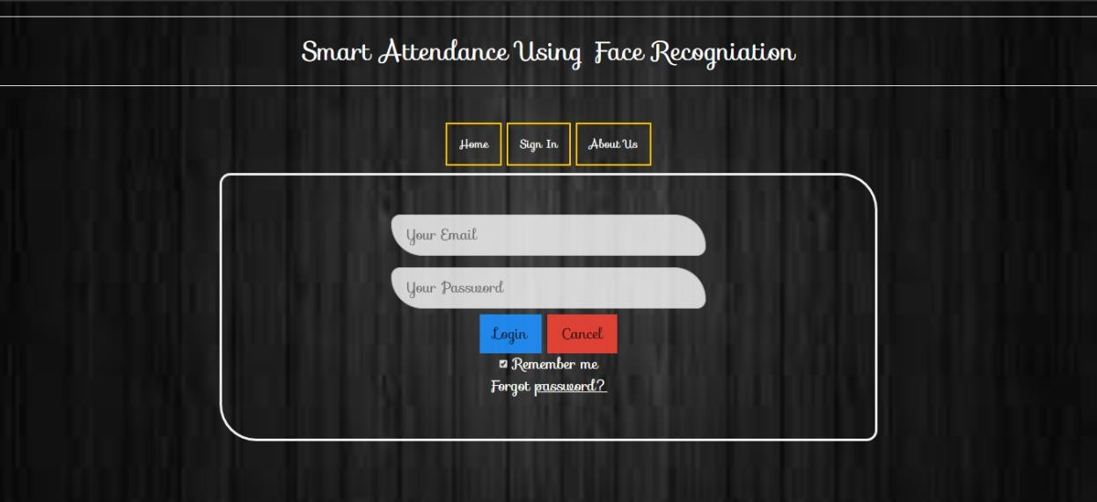

**Fig 7.5 staff login**

Above fig show the login page for staff by using this web pages staff can login. For successful login staff need a valid username and password that was already given them at the time of registration. This is the first step to enter in the system.

After successful login below shown window will be appeared.

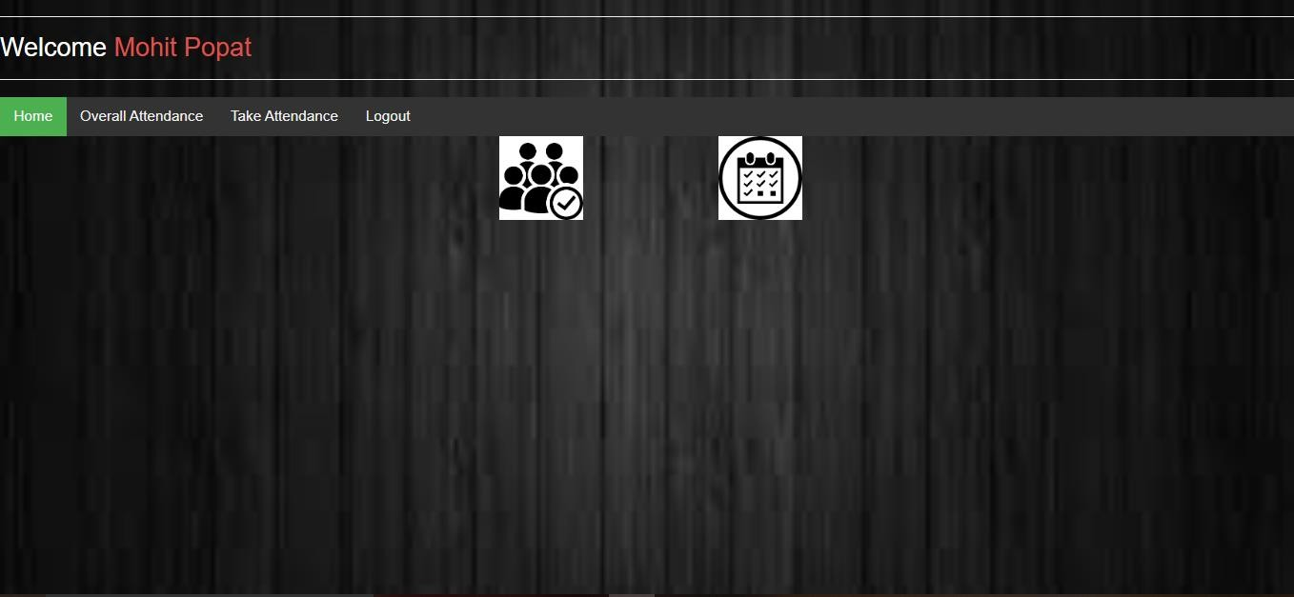

**Fig 7.6 staff home page**

In this staff having two option first is take attendance and another one is view attendance.

Take attendance:

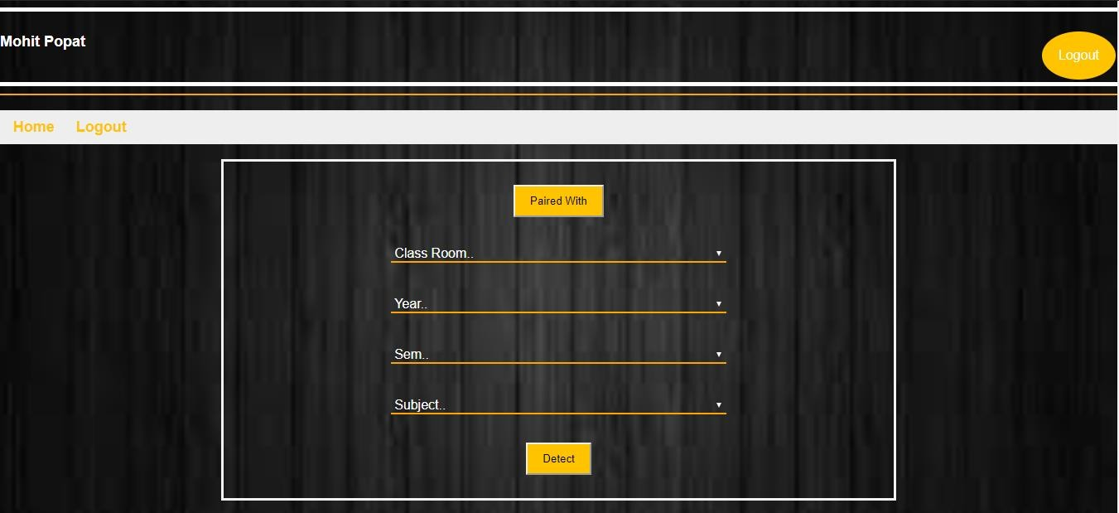

**Fig 7.7 take attendance**

As well as system having option of manual attendance.

Manually take attendance:

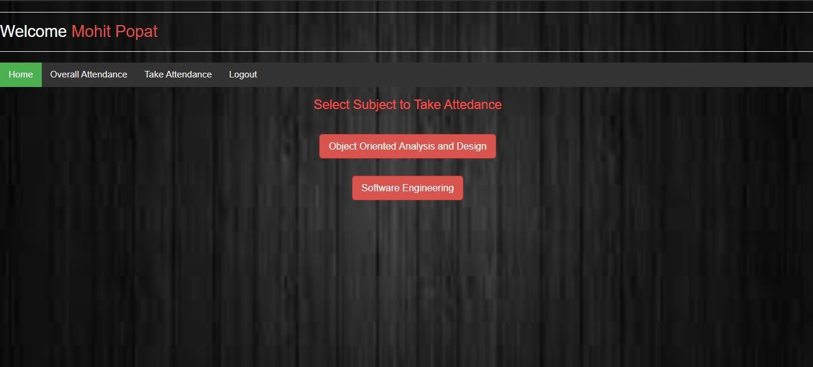

**Fig 7.8 manually take attendance page1**

After click on subject name following window will be appeared.

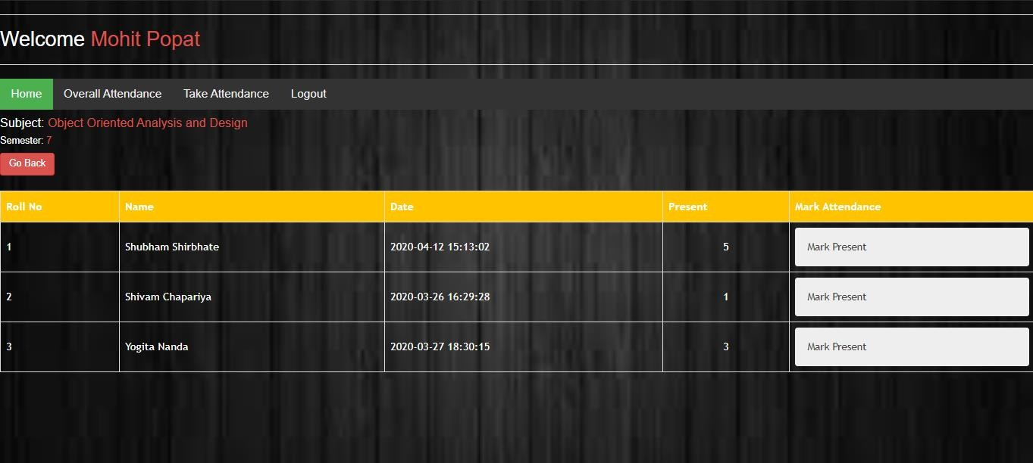

**Fig 7.9 Manually take attendance page2**

Mark attendance following way

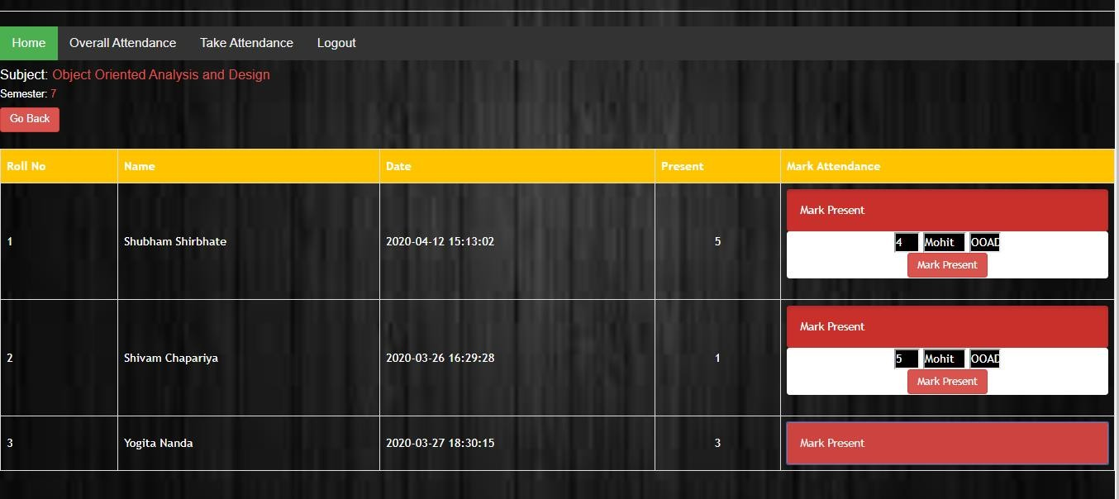

**Fig 7.10 manually take attendance page3**

Now view attendance option. As clicking on view attendance following window is appeared. This window shows the subject wise attendance.

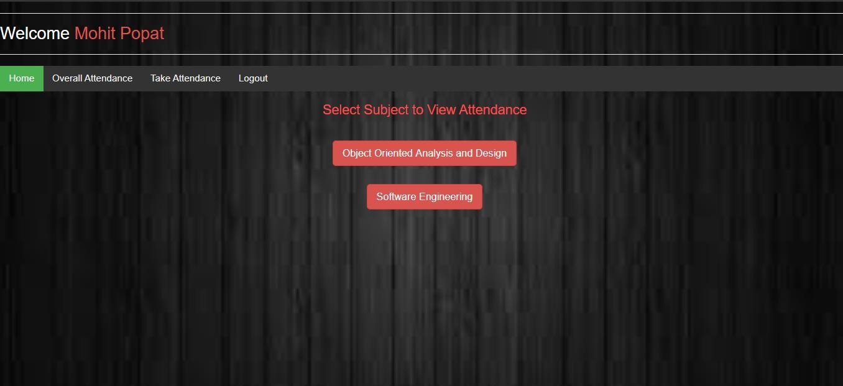

**Fig 7.11 view attendance**

While clicking on subject name below shown window is appeared.

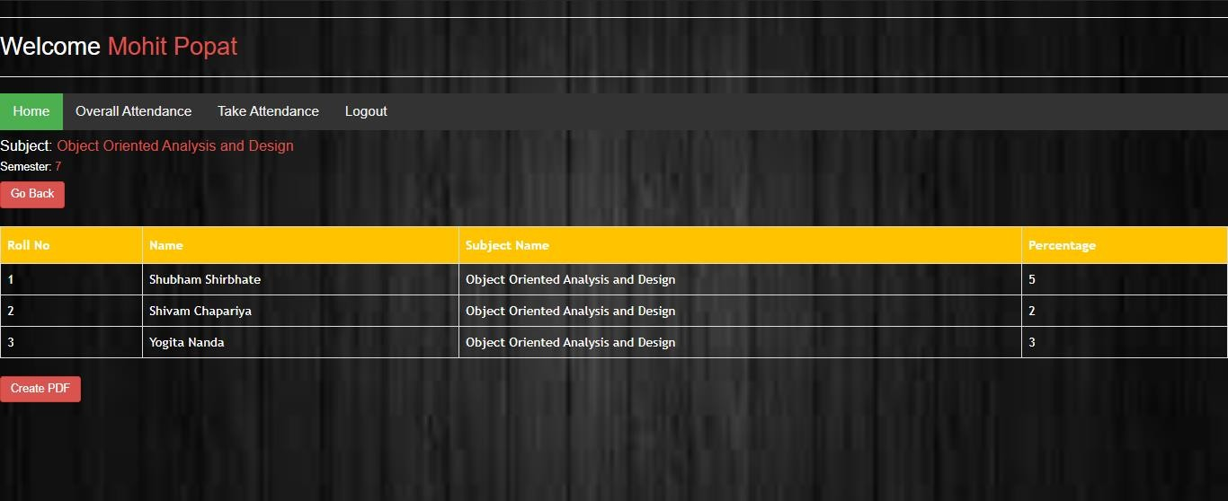

**Fig 7.12 view attendance subject wise**

After that clicking on student name student wise attendance will be displayed.

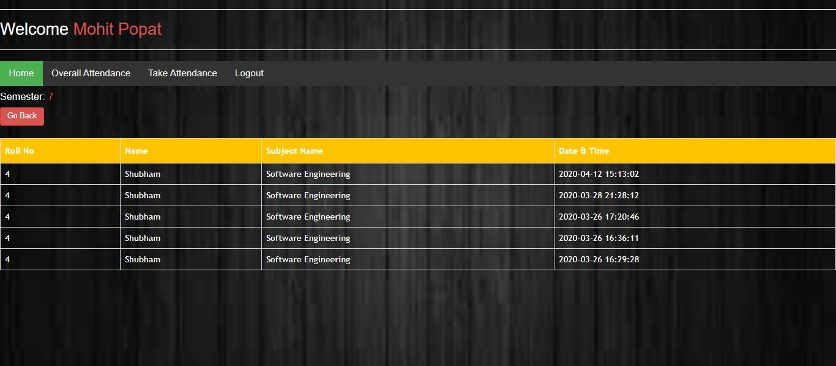

**Fig 7.13 view attendance student wise**

**HOD module: -**

**Login: -**



**Fig 7.14 HOD login**

Above fig show the login page for HOD by using this web pages HOD can login. For successful login staff need a valid username and password that was already given them at the time of registration. This is the first step to enter in the system.

After successful login below shown window will be appeared.

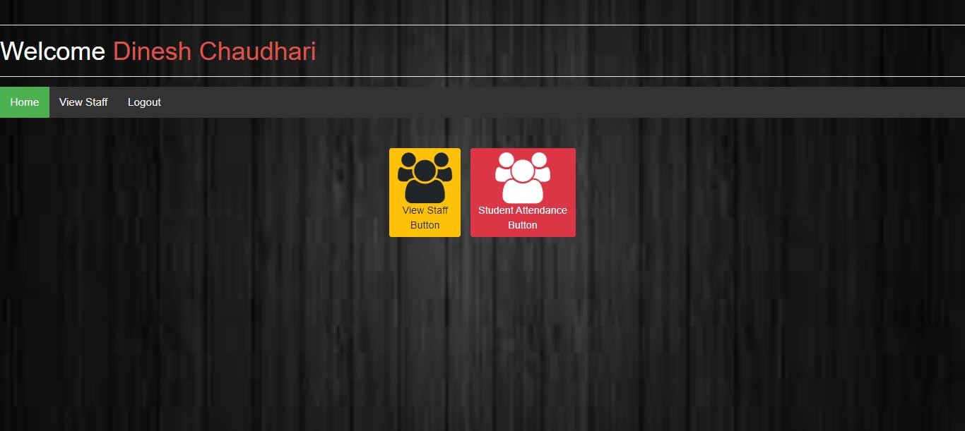

**Fig 7.15 HOD home page**

While click on view staff button following window will be appeared.

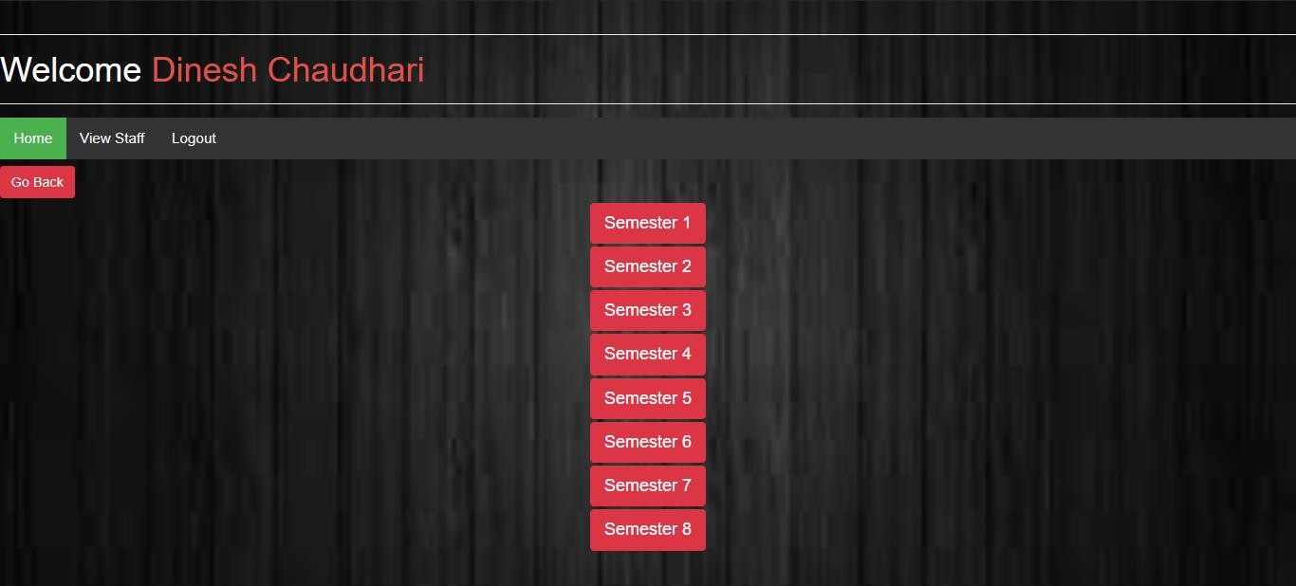

**Fig 7.16 view attendance semester wise**

While click on any semester button as per semester window will be appear.

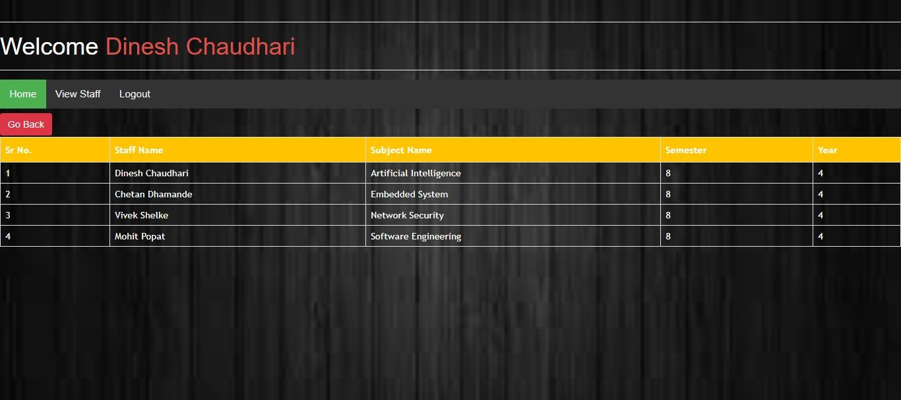

**Fig 7.17 view attendance subject wise**

**Admin Module: -**

**Registration: -**

Below fig shows the page for admin registration.

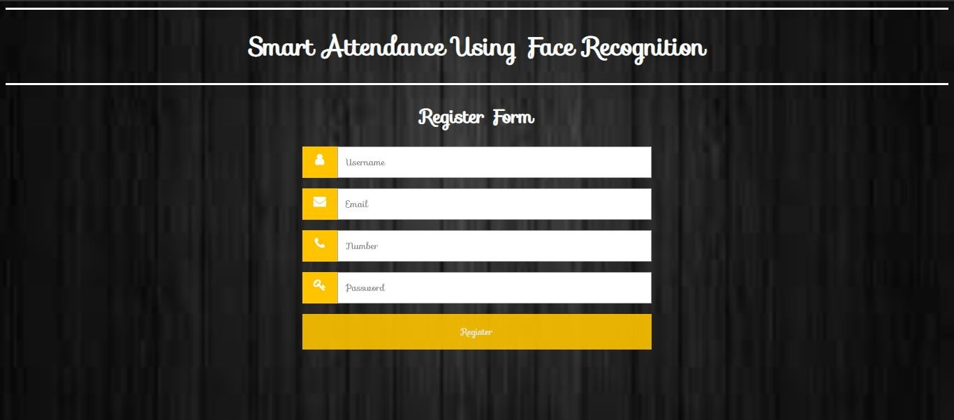

**Fig7.18 admin registration page**

## Admin login:

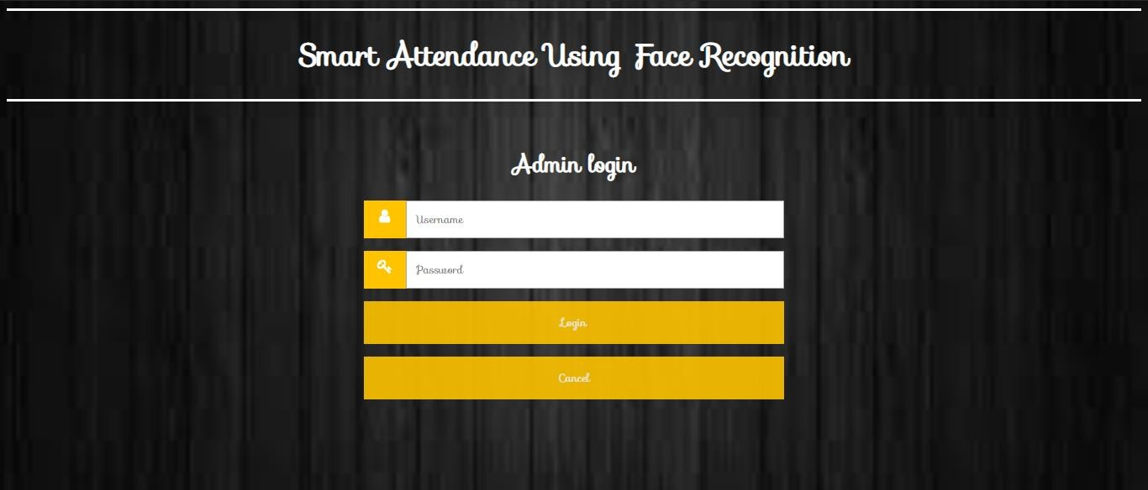

**Fig 7.19 admin login page**

Above fig show the login page for admin by using this web pages admin can

login.

## Student Registration:

To use this smart attendance system each one need to registered with this system. For registering student need to contact with admin. Then admin fill all the

required details and generates unique id. And also assign unique username and password

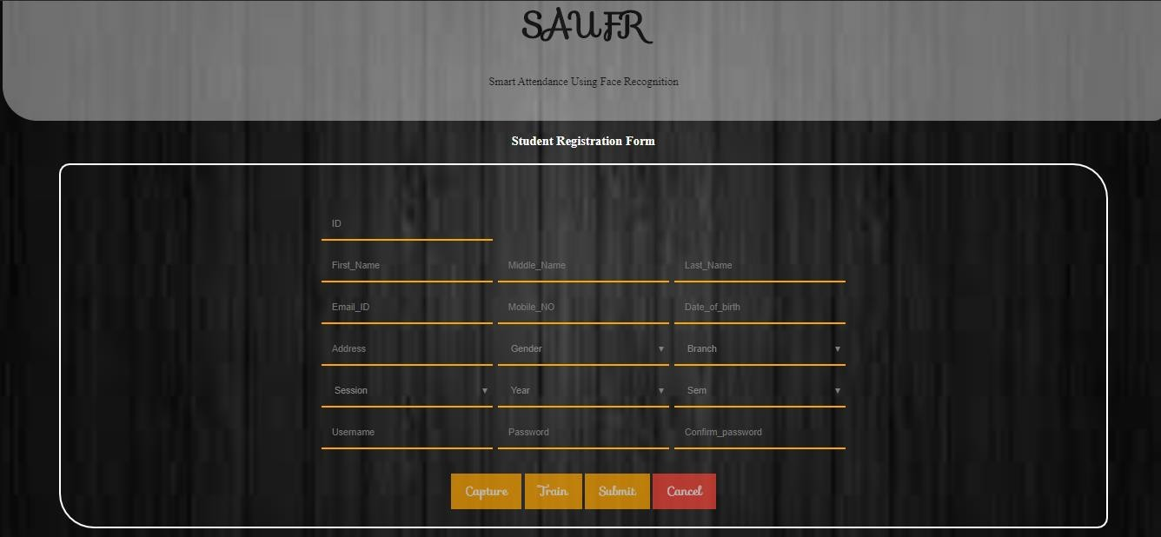

**Fig 7.20 student registration page**

Above fig shows the registration form for student registration. By using this student can be registered.

## Capture image: -

After filling the details faces can be need to capture by clicking on the capture button. Below fig show the face capturing window. It takes up to 30 images.

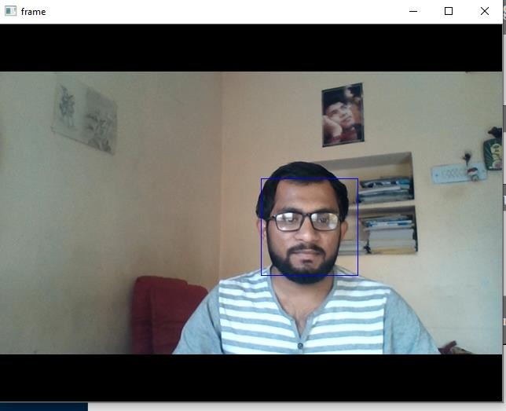

**Fig 7.21 capture images**

## Train image: -

After capturing the images needs to train that images. below fig shows the trained images stored in folder. With id, name and count like this 1.shubham.1, 1.shubham.2, 1.shubham.3, 1.shubham.30. After train images by clicking on

submit button. Student gets registered.

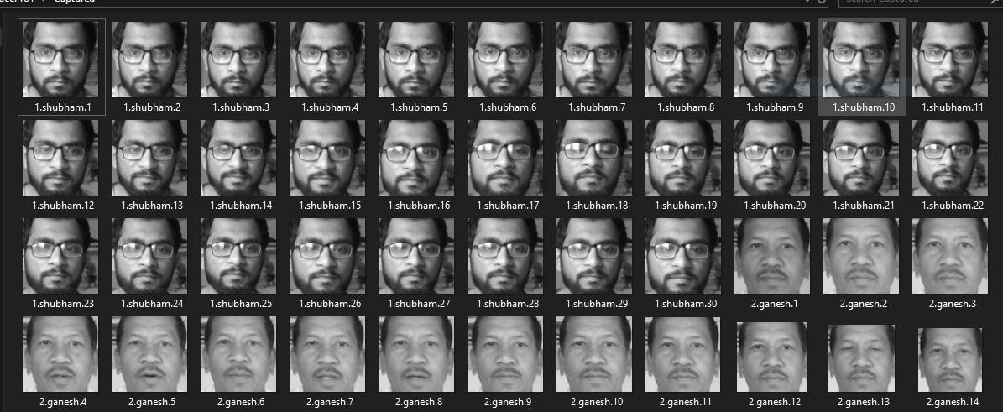

**Fig 7.22 trained images**

## Staff Registration:

To use this smart attendance system each one need to registered with this system. For registering staff need to contact with admin. Then admin fill all the required details and generates unique id. And also assign unique username and password.

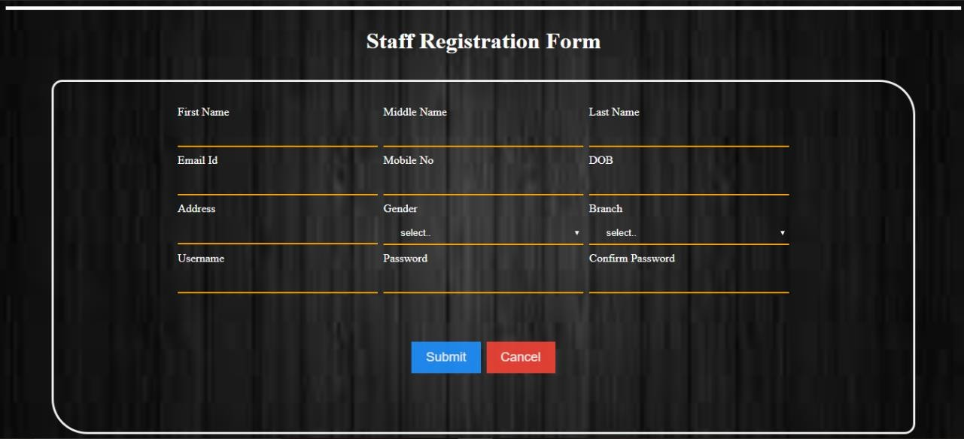

**Fig 7.23 staff registration page**

Above fig shows the registration form for staff registration. By using this staff can be registered.

## HOD Registration: -

To use this smart attendance system each one need to registered with this system. For registering HOD need to contact with admin. Then admin fill all the required details and generates unique id. And also assign unique username and password.

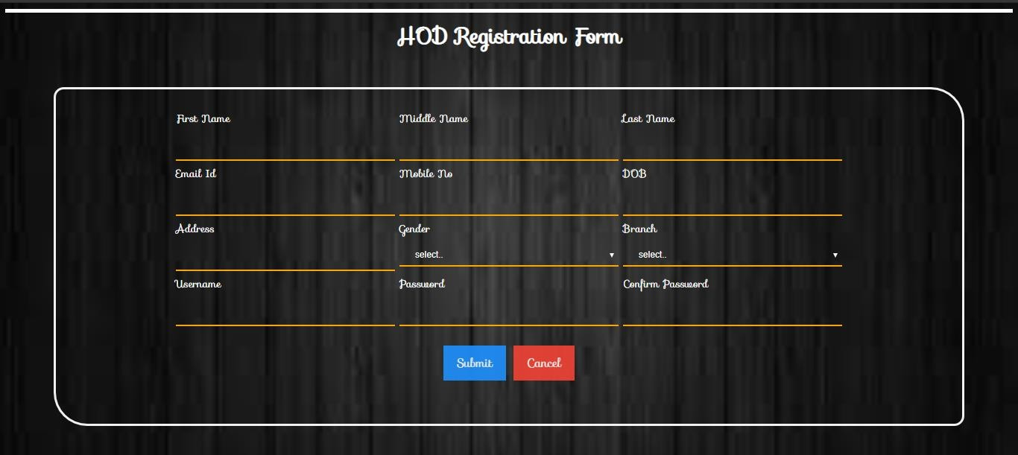

**Fig 7.24 HOD registration page**

Above fig shows the registration form for HOD registration. By using this HOD can be registered.

# CHAPTER 8 TESTING

All the modules of Smart Attendance Using Face Recognition have gone through following testing:

System testing is the expensive and time-consuming process. There are two strategies for testing software that we use for testing our system: Code Testing and Specification Testing. In Code testing, we developed those cases to execute every instructions and path in the program. In specification testing, we examined the program specification and then wrote test data to determine how the program operates under specified condition.

Client Acceptance

Needs Testing

Requirements System

Testing

Design Integration

Testing

Code Unit

Testing

We have tested each module separately i.e. have completed unit testing first and system testing was done after combining /linking all different Modules with different menus and thorough testing was done. Testing is a very important part of SDLC and takes approximately 50% of the time.

Once the system is a live one, Maintenance phase is important. Service after sale is a must and users/ clients must be helped after the system is implemented. If he/she faces any

problem in using the system, one or two trained persons from developer’s side can be deputed at the client’s site, so as to avoid any problem and if any problem occurs immediate solution may be provided.

## Overview of Testing:

*Testing:*

Testing involves executing the program using sample data and inferring from the output whether the software performs correctly or not. This can be done either during module development (unit testing) or when several modules are combined (system testing).

*Defect Testing:*

Defect testing is testing for situation where the program does not meet its fictional specification. Performance testing tests a system's way to ensuring that the program meets its non-functional requirements.

*Debugging:*

Debugging is a cycle of detection, location, repair and test. Debugging is a hypothesis testing process. When a bug is detected, the tester must form a hypothesis about the cause and location of the bug. Further examination of the execution of the program (possible including many returns of it) will usually take place to confirm the hypothesis. If the hypothesis is demonstrated to be incorrect, a new hypothesis must be formed. Debugging tools that show the state of the program are useful for this, but inserting print statements is often the only approach. Experienced debuggers use their knowledge of common and/or obscure bugs to facilitate the hypothesis testing process. After fixing a bug, the system must be reset to ensure that the fix has worked and that no other bugs have been introduced. This is called regression testing. In principle, all tests should be performed again but this is often too expensive to do.

## Test Planning:

Testing needs to be planned to be cost and time effective. Planning is setting out standards for tests. Test plans set out the context in which individual engineers can place their own work. Typical test plan contains:

## Overview of testing process:

* + - Requirements trace ability
    - List of items to be tested
    - Schedule
    - Recording procedures so that results can be audited
    - Hardware and software requirements.

## OVERVIEW OF TESTING STRATEGIES:

Large system usually tested using a mixture of strategies. Different strategies may be needed for different parts of the system or at a stage of the process.

* + 1. *Top - Down Testing:*

This approach tests high levels of system before detailed components. This is an appropriate when developing the system top-down likely to show up structural design errors early (and therefore cheaply) has advantage that a limited, working system available early on. Validation (as distinct from verification) can begin early. Its disadvantage is that stubs needs to be generated (extra effort) and might be impracticable if component is complex (e.g. converting an array into a linked list; unrealistic to generate random list; therefore, end up implementing unit anyway). Test output may be difficult to observe (needs creation of artificial environment). This is not appropriate for OO systems (except within a class).

* + 1. *Bottom- Up Testing:*

This is opposite of top-down testing. This testing test low-level unit then works up hierarchy. Its advantages and disadvantages of bottom-up mirror those of top-down. In this testing there is need to write test drivers for each unit. These are as reusable as the unit itself. Combining top-down development with bottom-up testing means that all parts of system must be implemented before testing can begin, therefore does not accord with incremental approach discussed above. Bottom-up testing less likely to reveal architectural faults early on. However, bottom-up testing of critical low-level components is almost always necessary. Appropriate for OO systems.

* + 1. *Black- box (Functional) Testing:*

Testing against specification of system or component. Study it by examining its inputs and related outputs. Key is to devise inputs that have a higher likelihood of causing outputs that reveal the presence of defects. Use experience and knowledge of domain to identify such

test cases. Failing this a systematic approach may be necessary. Equivalence partitioning is where the input to a program falls into a number of classes. E.g. positive numbers vs. negative numbers. Programs normally behave the same way for each member of a class. Partitions exist for both input and output. Partitions may be discrete or overlap. Invalid data (i.e. outside the normal partitions) is one or more partitions that should be tested.

* + - * Black box testing is done to find incorrect or missing function
      * Interface error
      * Error in external databases
      * Performance error
      * Initialization and termination error

Test cases are chosen to exercise each portion. Also test boundary cases (atypical, extreme, zero) since these frequently show up defects. For completeness, test all combinations of partitions. Black box testing is rarely exhaustive (because one doesn't test every value in an equivalence partition) and sometimes fails to reveal corruption defects caused by "weird" combination of inputs. Black box testing should not be used to try and reveal corruption defects caused, for example, by assigning a pointer to point to an object of the wrong type. Static inspection (or using a better programming language!) is preferable for this.

* + 1. *White- box (Structural) Testing:*

Testing based on knowledge of structure of component (e.g. by looking at source code). Advantage is that structure of code can be used to find out how many test cases need to be performed. Knowledge of the algorithm can be used to identify the equivalence partitions. Path testing is where the tester aims to exercise every independent execution path through the component. All conditional statements tested for both true and false cases. If a unit has n control statements, there will be up to 2n possible paths through it. This demonstrates that it is much easier to test small program units than large ones. Flow graphs are a pictorial representation of the paths of control through a program. Use flow graph to design test cases that execute each path. Static tools may be used to make this easier in programs that have a complex branching structure. Tools support. Dynamic program analyzers instrument a program with additional code. Typically, this will count how many times each statement is executed.

# CHAPTER 9 ADVANTAGES

This system implementation helps to achieve various tedious tasks arise in manual attendance system in very easy and efficient manner.

* + - * It consistently maintains daily data entry in attendance record without any errors.

To avoid the difficulty of taking attendance of large number, there is a

need of automated attendance system that is fast and reduces the chance of fake attendance.

* + - * This system is easy and convenient to use and has ability handle data.

In this technology system is developed for deploying an easy and a secure way of taking down attendance. This attendance is recorded, by continuously detecting faces of students via camera as they enter the classroom.

* + - * This system saves both time and expense because data maintain indefinitely on the database.

The management of the attendance can be a great burden on the teachers if it is done by hand and takes lot of time so Automated system consumes the time.

# CHAPTER 10 CONCLUSION & FUTURE SCOPE

## 10.1. Conclusion:

To conclude, Smart Attendance Using Facial Recognition System has been envisioned for the purpose of reducing the errors that occur in the traditional (manual) attendance taking system. The aim is to automate and make a system that is useful to the organization such as an institute. This method is secure enough, reliable and available for use. No need for specialized hardware for installing the system in the office. It can be constructed using a camera and computer. It overcomes the many limitations incorporated in the attendance. It provides Easy implementation Environment and Generate attendance report flexibly.

## Future Scope:

The System has a very vast scope in future. The System can be implemented on intranet in future. System can be updated in near future as and when requirement for the same arises, as it is very flexible in terms of expansion. With the proposed system of database is ready and fully functional the client is now able to manage and hence run the entire work in a much better, accurate and error free manner.

The following are the future scope for the system.

* + - Discontinue of particular student eliminate potential attendance.
    - Bar code Reader based attendance system.
    - Individual Attendance system with photo using Student login.

**REFERENCES**

[1]. Nandhini R, Duraimurugan N, S.P.Chokkalingam, “Face Recognition Based Attendance System”, International Journal of Engineering and Advanced Technology (IJEAT) ISSN: 2249 – 8958, Volume-8, Issue-3S, February 2019

1. Venkata Kalyan Polamarasetty, Muralidhar Reddy Reddem, Dheeraj Ravi, Mahith Sai Madala “Attendance System based on Face Recognition”, IRJET e-ISSN: 2395-0056.
2. K.SenthamilSelvi, P.Chitrakala, A.AntonyJenitha, “Face recognition based Attendance marking system” IJCSMC, Vol. 3, Issue. 2, February 2014, pg.337 – 342
3. Mr.C.S.Patil, Mr.R.R.Karhe, Mr.M.D.Jain, “Student Attendance Recording System Using

Face Recognition with GSM Based” International Journal of Research in Advent Technology, Vol.2, No.8, August 2014 E-ISSN: 2321-9637

1. Muhammad Fuzail, Hafiz Muhammad Fahad Nouman, Muhammad Omer Mushtaq, Binish Raza, Awais Tayyab, Muhammad Waqas Talib, “Face Detection System for Attendance of Class’ Students” International journal of multidisciplinary sciences and engineering, vol. 5, no. 4, April 2014
2. Mathana Gopala Krishnan, Balaji, Shyam Babu, “Implementation of Automated Attendance

System using Face Recognition” International Journal of Scientific & Engineering Research, Volume 6, Issue 3, March-2015